Project Report

Hashing: Querying in Face Datasets

Name: Revanth Kalluri
Course: AI & ML (Batch-5)
Problem Statement: Build a Hashing Model for images.

Prerequisites:
Software used and how I installed them:
Python 3.6: Download and install anaconda using https://www.anaconda.com/download/. After installing anaconda, install below modules(packages), using anaconda prompt to run the commands.
Module | Command
numpy | pip install numpy
pandas | pip install pandas
matplotlib | pip install matplotlib
cv2 | pip install opencv-python

Pip is a package manager for python packages. Run “pip --version” in anaconda prompt to verify if pip is already installed. Run “conda install pip” to install pip for the first time.

Dataset used:
The data source used for this project is grayscale images from Yale Face Database. The database is publicly available for non-commercial use.

Method used:
Locality Sensitive Hashing.

1. Importing necessary modules:
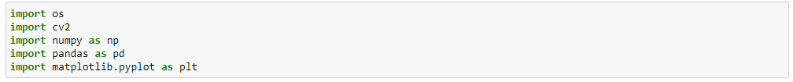
2. Read images and store it in required format:
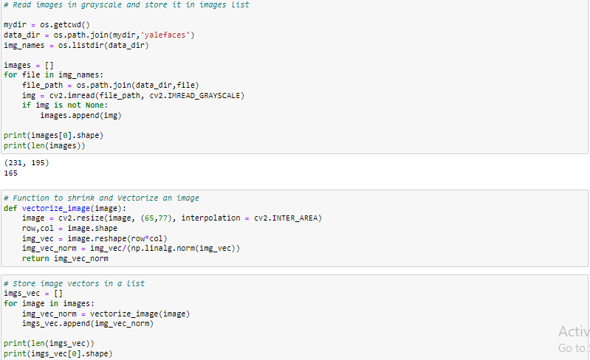
3. Function for Hashing:
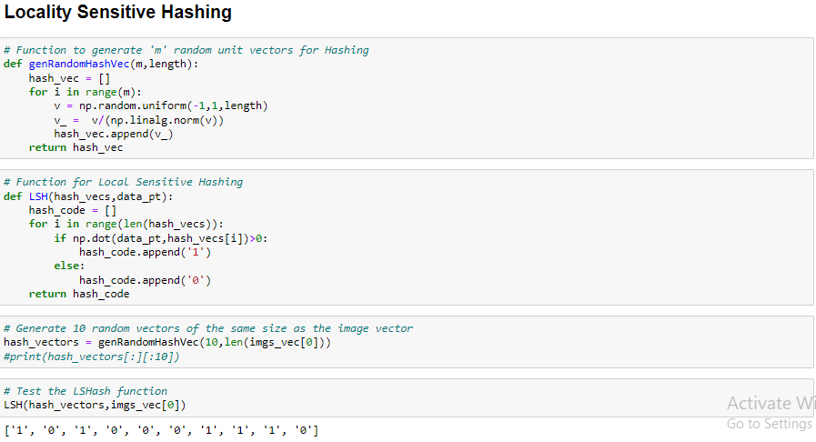
4. Divide images in feature subspace using hashing:
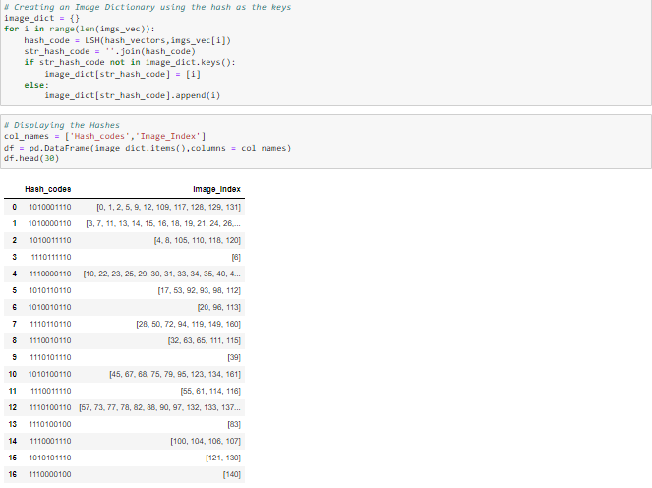
5. Plot query image:
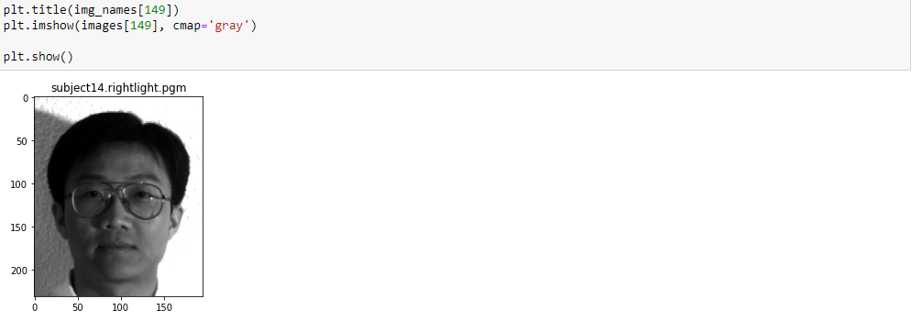

6. Create hash for query image and plot the images in same hash for comparison:
